* **ORIGINAL DATASET** : ilpd.csv
  + Total observations : 583
  + Total Null values : 4
  + Total Duplicate Values : 13
  + # Column Non-Null Count Dtype
  + --- ------ -------------- -----
  + 0 age 583 non-null int64
  + 1 3 gender 583 non-null object
  + 2 t_bilirubin 583 non-null float64
  + d_bilirubin 583 non-null float64
  + 4 alkphos 583 non-null int64
  + 5 sgpt 583 non-null int64
  + 6 sgot 583 non-null int64
  + 7 t_protein 583 non-null float64
  + 8 albumin 583 non-null float64
  + 9 a_g_ratio 579 non-null float64
  + 10 result 583 non-null int64
* COLAB NOTEBOOK 1 : liver_cd_data_preparation_1.ipynb

Handled duplicate values *(Dropped)*

Handled null values *( Simple Imputation - Median value )*

Handled categorical values : *(OHE on gender)*

Modified dataset : **ilpd_md1.csv**

* COLAB NOTEBOOK 2 : liver_cd_data_preparation_2.ipynb

Handled Outliers *(z score method for normally distributed data & IQR method for Skewed data)*

Handled Data Distribution *(Normalisation-standard Scaling)*

Modified dataset : **ilpd_md2.csv (Handled Outliers)**

**ilpd_md3.csv (Handled Outliers + Scaling )**

**Report attached below (fig 1,2,3)**

**Before Handling Outliers**

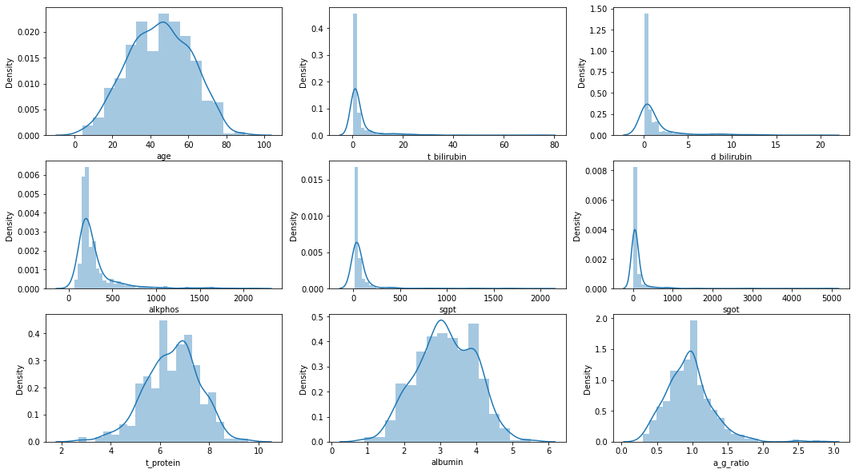

# Distplots Summary and Observation

**Normal distributed data :**

**age, t_protein, albumin, a_g_ratio**

**Skewed Distributed data :**

**t_bilirubin, d_bilirubin, alkphos, sgpt, sgot**

**Conclusion : For outlier detection**

**Z-Score method is used for Normal Distributed data**

**IQR Method is used for Skewed Distributed data**

**After Handling Outliers**

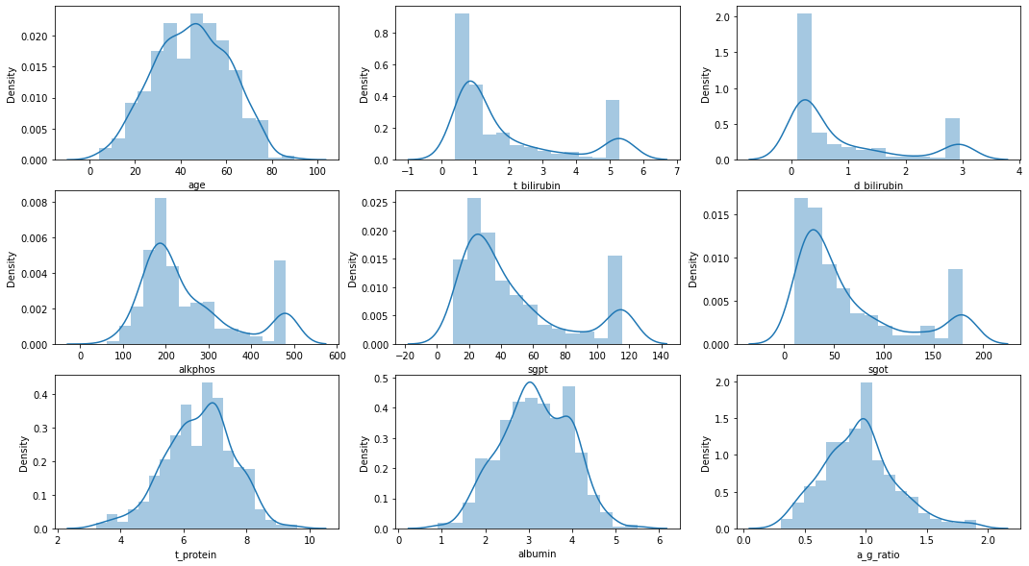

**After Scaling Data (Normalisation)**

